TRAINING REPORT
AUTOMATIVE ELECTRONICS



SUBMITTED BY: DEEPANSH MADAN

EMP ID:213458

Contents
1 TABLE OF FIGURES 3
2 MODULE DESIGN AND IMPLEMENTATION OF WIPER SYSTEM 4
2.1 CIRCUIT DESIGN 4
2.2 SIMULATION RESULT 4
https://www.tinkercad.com/things/diPfzxvVoTy-wiper-system-shiny-migelo/editel?sharecode=obhJcuppSEly7eiN8WKtTH4HIzR4fJXjlMp8T5j6Xa4= 4
2.3 EMBEDDED C CODE USING API 5
3 ILLUSTRATE RISC AND CISC ARCHITECTURE 7
3.1 RISC 7
3.2 CISC 7
4 BLOCK DIAGRAM OF COFFEE VENDING MACHINE ECU AND ITS DESIGN CHALLENGE CHART 8
4.1 BLOCK DIAGRAM 8
5 VON- NEUMAN AND HARVARD ARCHITECTURE 9
6 ASSOCIATIVITY OF OPERATORS IN C LANGUAGE 10
7 RGB interfacing on Tinkercad 11
7.1 Circuit Design 11
7.2 Simulation Result 11
7.3 Code 11
8 Size of Serial Registers in Atmega 328P 12
9 Frames in Ethernet 12
10 Prescalar 12
11 Simulator and Emulator 12

TABLE OF FIGURES

Figure 1Wiper System Circuit 4
Figure 2Block Diagram of Coffee Vending Machine 8
Figure 3Design Challange Chart of Coffee Vending MachineDESIGN CHALLENGE CHART 8
Figure 4Associativity Table 10
Figure 5RGB Interfacing Circuit Diagram 11

About KPIT
KPIT Technologies Limited co-founded in 1990 by Ravi Pandit and Kishor Patil, as KPIT Infosystems is an Indian multinational corporation. It provides IT Consulting and ProductEngineering solutions and services to Automotive and Transportation. Lead by Ravi Pandit, Kishor Patil, Sachin Tikekar, the company’s vision is to re-imagine mobility for creation of a cleaner, smarter and safer world. The company has adopted values which can be defined by the seven letters of the word ‘CRICKET’ - C - Customer Focus, R - Respect for Individual , I- Integrity, C- Community contribution, K – Knowledge Worship , E – Entrepreneurship and Innovation, T- Teamwork and Boundary - Less- Ness.
It merged with Cummins Infotech in 2002 and became KPIT Cummins Infosystems Ltd, later in September 2013 it changed its name to "KPIT Technologies Limited". In January 2018, Birlasoft, an IT company, merged and immediately split into two new companies, an IT company and another automotive company. The IT Company will work under the name of Birlasoft, and the automotive company will work under the name of KPIT Engineering (KEL)
In this journey of innovation from 1990 the company has been recognized from the United Nations for contribution to advancing Energy for Sustainable Transport, Public Transport Strategy by UITP – International Association of Public Transport KPIT’s ITS recognized at The European IDTechEx Energy Harvesting & IoT Awards 2015 and Honored with Wall Street Journal Innovation Award in the ‘Transport’ category, Volvo Buses India with Project Development Excellence Award 2014. KPIT has bagged awards in 2016 for Promising Transport Innovation Award at the International Transport Forum Summit, in Germany for REVOLO, One Globe Award for Excellence in Research & Development for its Smart Electric Bus technology and Order of Merit Award at BW Businessworld Smart Cities Conclave & Awards 2016.
The company has worked in the domains of Autonomous Driving and ADAS, Electrical and Conventional Powertrain, Connected Vehicle, Vehicle Diagnostic, AUTOSAR with clients such as Cummins, Paccar, and Lafarge and has generated a revenue of US$567.64 million in 2017-2018

Block Diagram of TPMS with its Input, Output and Control Logic

Block Diagram
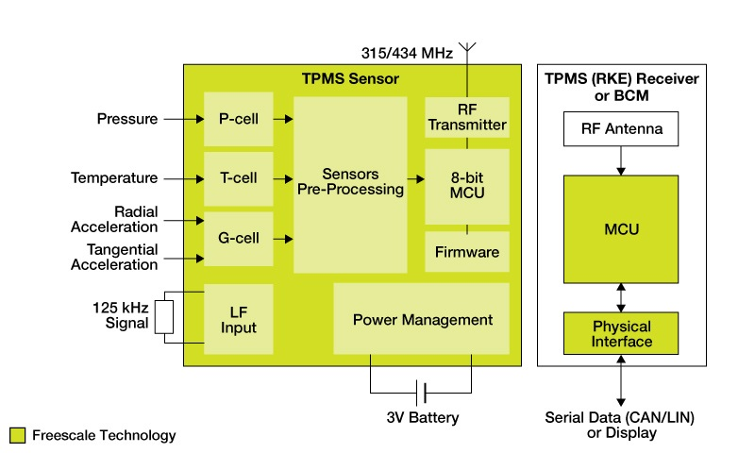

INPUTS and OUTPUTS
- INPUTS:
- Pressure
- Temperature
- Radial Acceleration
- Tangential Acceleration
- Clock Source
- Power Source
- RF receiver at the BCM Module
- Serial Data Input (CAN/LIN)
- OUTPUTS:
- RF Transmitter at the TPMS Module
- Serial Data output(CAN/LIN)

Control Logic
Inputs are taken from a pressure senor inside the tyre, apart from that Temperature is also taken into account as high temperature will lead in bursting of tyre. Radial and Tangential acceleration are considered to find the actual pressure of the tyre. The input data is fed into a preprocessor to convert raw data into useful data which is then given to MCU. If the pressure exceeds min/max the threshold values, a signal is sent to the BCU via RF transmitter.

Agile Methodology
- AGILE methodology is a practice that promotes continuous iteration of development and testing throughout the software development lifecycle of the project. Both development and testing activities are concurrent unlike the Waterfall model
- The agile software development emphasizes on four core values.
- Individual and team interactions over processes and tools
- Working software over comprehensive documentation
- Customer collaboration over contract negotiation
- Responding to change over following a plan
- The agile process is broken into individual models that designers work on. Small projects can be implemented very quickly. For large projects, it is difficult to estimate the development time.
- The customer has early and frequent opportunities to look at the product and make decision and changes to the project
- Error can be fixed in the middle of the project
- The most widely-used Agile methodologies include:
- Agile Scrum Methodology
- Lean and Kanban Software Development
- Extreme Programming (XP)
- Crystal
- Dynamic Systems Development Method (DSDM)
- Feature Driven Development (FDD)

Summary of Videos in Automotive Domain

V- Model

Structure of V-Model

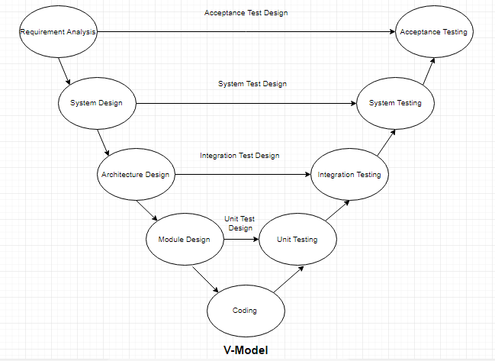

Structure of V-Model
- V-Model, also known as Verification and Validation model is based on the association of a testing phase for each corresponding development stage.
- Development of each step directly associated with the testing phase. The next phase starts only after completion of the previous phase i.e. for each development activity, there is a testing activity corresponding to it.
- Phases of V- Model are given below
- Requirement Analysis

This is the first phase in the development cycle where the product requirements are understood from the customer’s perspective. This phase involves detailed communication with the customer to understand his expectations and exact requirement. This is a very important activity and needs to be managed well, as most of the customers are not sure about what exactly they need. The acceptance test design planning is done at this stage as business requirements can be used as an input for acceptance testing

- System Design

The system design will have the understanding and detailing the complete hardware and communication setup for the product under development. The system test plan is developed based on the system design. Doing this at an earlier stage leaves more time for the actual test execution later.

- Architecture Design

System design is broken down further into modules taking up different functionalities. The data transfer and communication between the internal modules and with the outside world (other systems) is clearly understood

- Module Design

In this phase the system breaks dowm into small modules. The detailed design of modules is specified, also known as Low-Level Design (LLD).

- Coding

The actual coding of the system modules designed in the design phase is taken up in the Coding phase. The best suitable programming language is decided based on the system and architectural requirements.

The coding is performed based on the coding guidelines and standards. The code goes through numerous code reviews and is optimized for best performance before the final build is checked into the repository.
- Unit Testing

Unit Test Plans are developed during module design phase. These Unit Test Plans are executed to eliminate bugs at code or unit level.
- Integration testing

After completion of unit testing Integration testing is performed. In integration testing, the modules are integrated and the system is tested. Integration testing is performed on the Architecture design phase. This test verifies the communication of modules among themselves.
- System Testing

System testing test the complete application with its functionality, inter dependency, and communication .It tests the functional and non-functional requirements of the developed application.
- Acceptance Testing (UAT)

UAT is performed in a user environment that resembles the production environment. UAT verifies that the delivered system meets user’s requirement and system is ready for use in real world.

BLOCK DIAGRAM
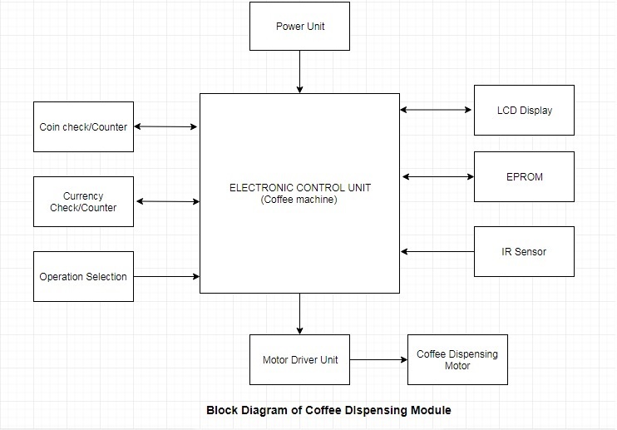
Figure 2Block Diagram of Coffee Vending Machine
Figure 3Design Challange Chart of Coffee Vending MachineDESIGN CHALLENGE CHART
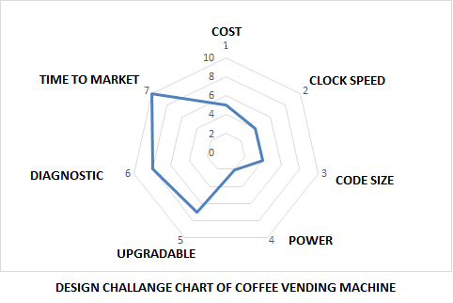

VON- NEUMAN AND HARVARD ARCHITECTURE

- VON-NEUMAN ARCHITECTURE
- Von- Neumann architecture is based on traditional design of storage of a software code, i.e. data and code is stored in a single physical memory in a continuous sequence.
- Processor requires multiple cycles to fetch (mostly 1 instruction), decode(mostly 1) , execute(1 or more) and store(1 or 2 ) the instruction.
- The number of cycles for each instruction is mostly same.
- Only one permanent memory is used to store code and data. In some architecture code is stored in the starting address followed by its corresponding data.
- While in others the starting address is a data (or vector address), which transfers the program control to initializing code.
- The architecture is simple and costs less.
- It has no pipelining and hence execution of instruction is slower but they are easy to handle.

- HARVARD ARCHITECTURE
- Harvard architecture or modern computer architecture is based on the concept of usage of different storage memories for data and code.
- Processor requires less number of cycles to complete one instruction i.e. fetch, decode, execute, storage.
- Steps like fetching, decode are processed in parallel or at same time, as data and code is stored at different places with separate buses for transfer of data
- The number of cycles for each instruction depends on the complexity of pipelining.
- Another important factor is efficient software code/program which reduces or omits bubbles in pipelining
- Due to efficient management of pipelining, control unit and management of buses is complex which increases the cost.

- APPLICATIONS
- Von-Neumann Architecture
- A Dataflow machine or state flow machine with less complex tasks and low memory usage or memory is used to access constants.
- Harvard Architecture
- Microcontrollers, DSP processors etc.

ASSOCIATIVITY OF OPERATORS IN C LANGUAGE
Associativity of operators in C language is the rule which determines the flow of logic in absence of parenthesis. It can be of two types i) Right to Left ii) Left to Right
The following table shows the associativity of different operators.

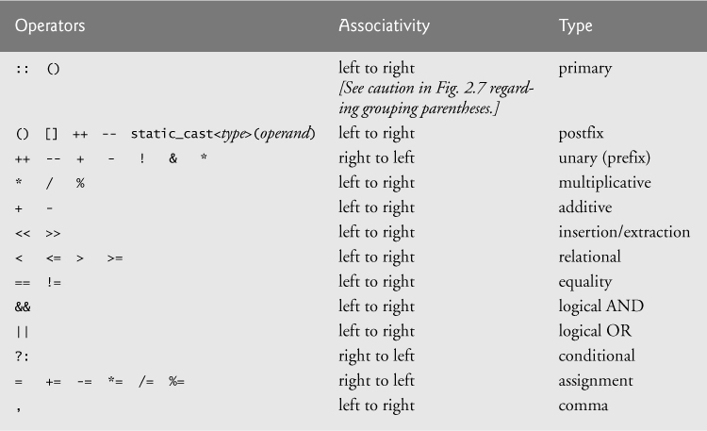
Figure 4Associativity Table
Link for image: - https://www.oreilly.com/library/view/c11-for-programmers/9780133439885/graphics/08fig05.jpg

RGB interfacing on Tinkercad

Circuit Design
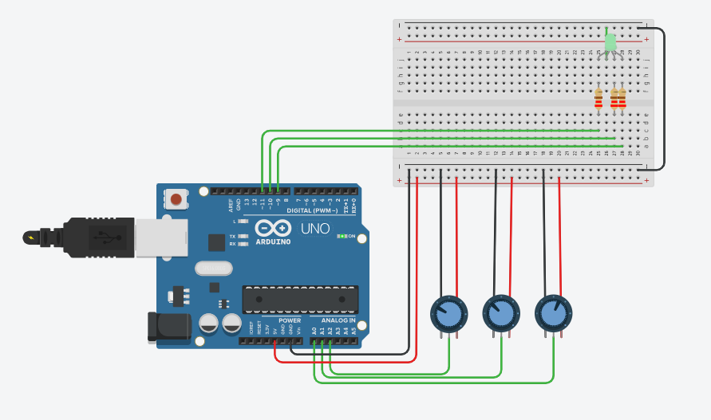
Figure 5RGB Interfacing Circuit Diagram

Simulation Result
https://www.tinkercad.com/things/1Elit1VaRJw-fabulous-luulia-wluff/editel?sharecode=78sJc9UUlyLqJQZMwmnWinzkuEYCBiPOEMVR5YRwhNE=

Code

void setup()
{
pinMode(9, OUTPUT);
pinMode(10, OUTPUT);
pinMode(11, OUTPUT);
pinMode(A0, INPUT);
pinMode(A1, INPUT);
pinMode(A2, INPUT);

}

void loop()
{
analogWrite(9 , ( analogRead(A0) / 4 ));
analogWrite(10 , ( analogRead(A1) / 4 ));
analogWrite(11 , ( analogRead(A2) / 4 ));
}

Size of Serial Registers in Atmega 328P
The size is 1 byte or 2 byte.

Frames in Ethernet
Frames of Ethernet range from 64 bytes to upto 1500 bytes

Prescalar
A prescalar is a counting circuit which reduces the frequency of an input signal by dividing the frequency by a prescaled value which is a power of 2. They can be used in timers, counters, ADC modules or analog inputs. Major use of prescalar is to write delay subroutines or to reduce CPU clock frequency for certain applications.

Simulator and Emulator
- Simulator
- Simulator works on the modeling of the system where each block is mimicked properly. The code runs through the proper methodology and presents the output.
- They can’t work with real time inputs
- They cannot be used for debugging.
- The host system cannot interact with the target system.
- Any changes in the hardware/target system cannot be reflected in simulation

- Emulators
- They do not copy the functionality of target system but rather interacts with the host system to give the output
- Majorly used for debugging.
- Real time inputs can be given.
- They use constant breakpoints to halt the processor and then copy its register, memory status values for displaying on the host system.
- Hence, they consume more time than actual run time of processor.
- Changes in the hardware/ target system cause a change in the emulator output.

